Project Design Phase-II
Data Flow Diagram & User Stories

Date | 08-12-2025
Team ID
Project Name | SHOPEZ : E-commerce Application
Maximum Marks | 4 Marks

Data Flow Diagrams:
The ShopEZ Data Flow-diagram represents the entities and relationships involved in an e-commerce system. It illustrates how users, products, cart, and orders are interconnected. Here is a breakdown of the entities and their relationships:
USER: Represents the individuals or entities who are registered in the platform.
Admin: Represents a collection with important details such as Banner image and Categories.
Products: Represents a collection of all the products available in the platform.
Cart: This collection stores all the products that are added to the cart by users. Here, the elements in the cart are differentiated by the user Id.
Orders: This collection stores all the orders that are made by the users in the platform.

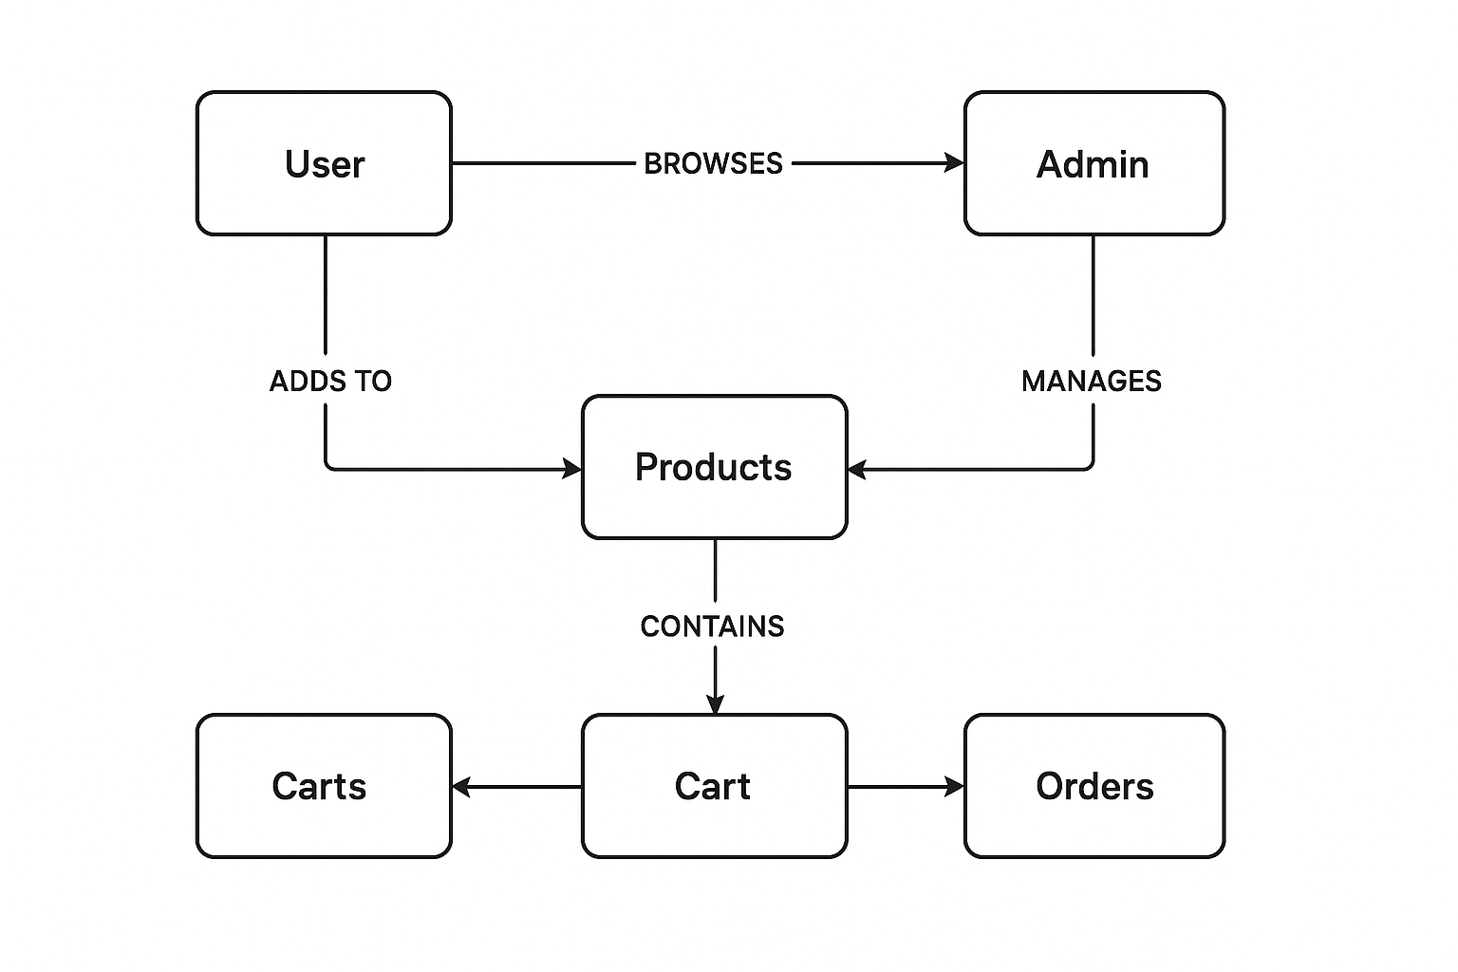

User Stories

User Story Table – Freelancing Application

User Type | Functional Requirement (Epic) | User Story / Task | Acceptance Criteria | Priority | Release
Client | Job Posting | As a client, I want to create a new freelance project with details and budget. | The project is displayed on the public listing page as well as in the client’s dashboard. | High | Sprint-1
Freelancer | Job Browsing | As a freelancer, I want to explore and refine job listings using categories or filters. | The filtering function shows accurate and relevant job opportunities based on selected criteria. | Medium | Sprint-2
Freelancer | Job Application | As a freelancer, I want to submit a proposal for a selected project. | The submitted proposal becomes visible to the hiring client for review. | High | Sprint-1
User (Client / Freelancer) | Messaging | As a user, I want to communicate with the other party using real-time chat. | Messages are delivered instantly and appear in both users’ chat windows without delay. | Medium | Sprint-2
Freelancer | Profile Management | As a freelancer, I want to modify my profile information and showcase my portfolio. | All updates are stored correctly and are reflected in my profile section. | High | Sprint-2
Client | Payment Processing | As a client, I want to complete secure payments after milestones or job completion. | The system logs each payment and displays it in the transaction records. | High | Sprint-2
User (Client / Freelancer) | Review System | As a user, I want to submit a rating or review once the project is completed. | The review appears on the respective user’s public profile. | Medium | Sprint-2
Admin | User Moderation | As an admin, I want to monitor flagged accounts and take corrective action when needed. | Every report and moderation action is recorded for audit purposes. | High | Sprint-1

